MAIN Registration Example:

Jeff is a U of Utah Neuroscience Faculty member who wishes to bring along their partner, Steve. Steve is attending the symposium and wants to stay overnight as well. Steve is not an employee or student at the University of Utah; therefore, Jeff must register using the MAIN Registration page.

Jeff will register as a U. Utah Faculty ($65) and fill out the information completely including their UNID.

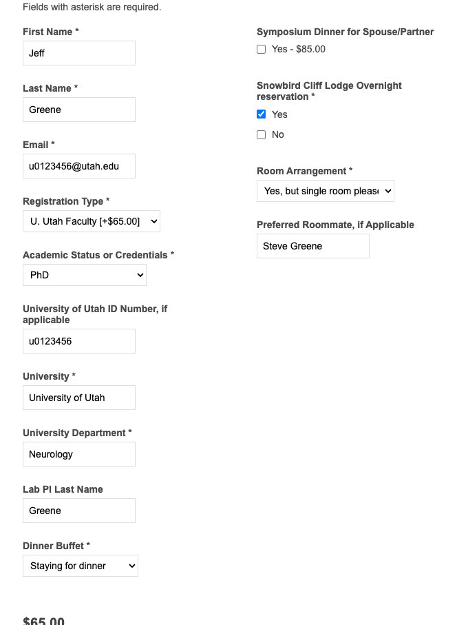
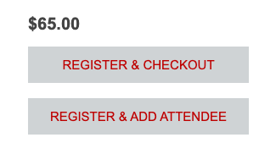
Before checking out, Jeff will register Steve by selecting REGISTER & ADD ATTENDEE. Note: Jeff does not need to purchase a dinner for Steve because Steve will be register for the symposium where dinner is included with the fee.

Next, Jeff will fill in form with Steve’s information and add his registration by choosing Other - Non-U. Utah ($250.00). (No need to select additional dinner). Jeff will select the overnight stay with the room arrangement of “Yes, room booked and shared with Registrant listed below”, enter his name and UPDATE the cart.

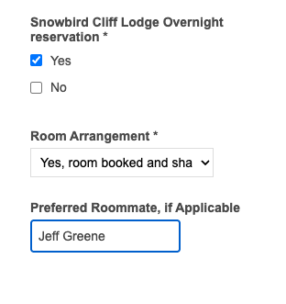

Finally, Jeff will review their order, click the box to “agree with the terms of service…” hit CHECKOUT. Jeff may choose to register an account or Checkout as a Guest. Follow the verification prompt and complete the billing page with credit card info to charge the $515.00 total. All Major Credit cards are accepted. Purchasing cards are not permitted for this transaction.

For addition help or questions, please contact the program manager @nicole@neuro.utah.edu

Sample Checkout:

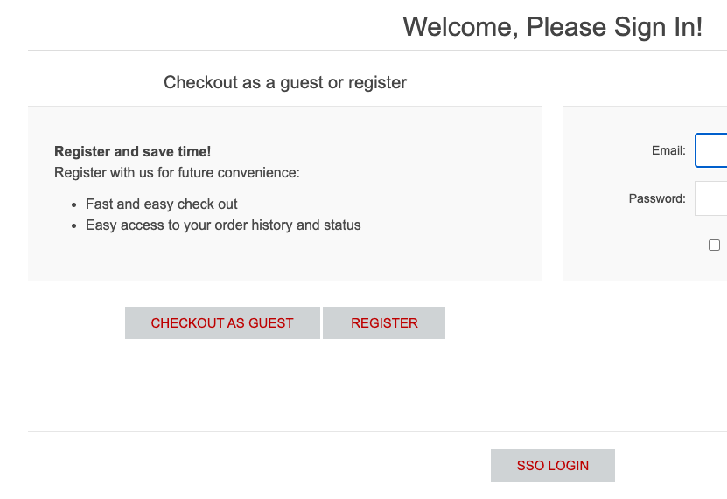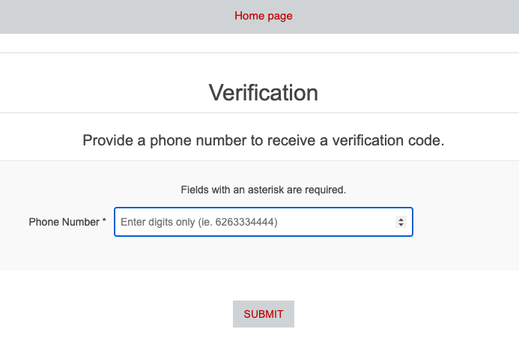
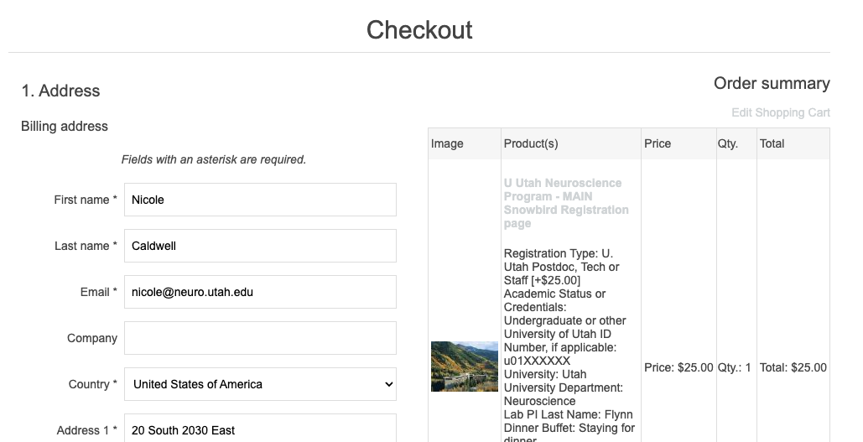
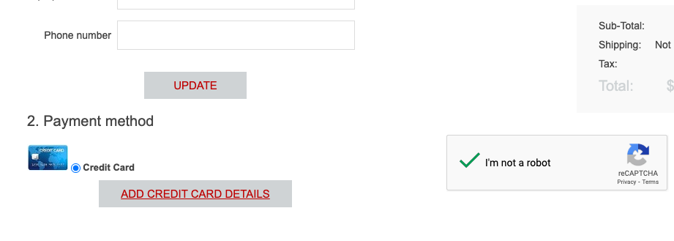

SELECT ADD CREDIT CARD DETAILS > enter credit card info and select check robot prompt and select NEXT. The next window will allow you to CONFIRM the order. You will receive an email from Utah Health Store indicating your order is received but not confirmed. An additional email will arrive once your order is confirmed, or your order required more information.

